Outside Recommenders with Common Application Schools
- Must sign your FERPA release authorization before any outside recommenders can be added to your account.

- Go to the “Recommenders and FERPA” section of a school in the My Colleges tab.

- Scroll down until you see the “Other Recommender” section. Click on the box to “Invite Other Recommender.”

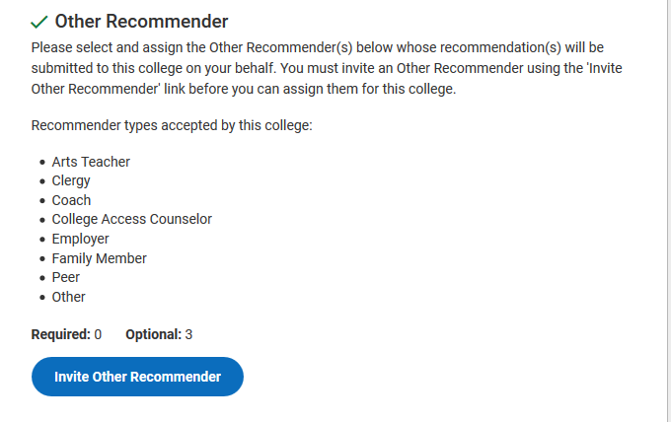
- Click on the box to select the “Other Recommender” you want to assign. Complete with full name and email address. This recommender will be added for this college only.

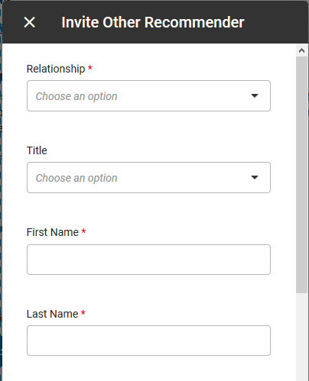
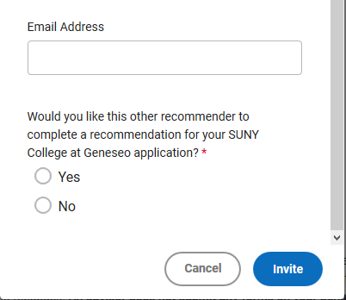
Over

- To assign an outside recommender to additional colleges, go to that college in your “My Colleges” tab. Click on “FERPA and Recommenders.” Use the drop down and click on the “Assign” button to add that recommender.

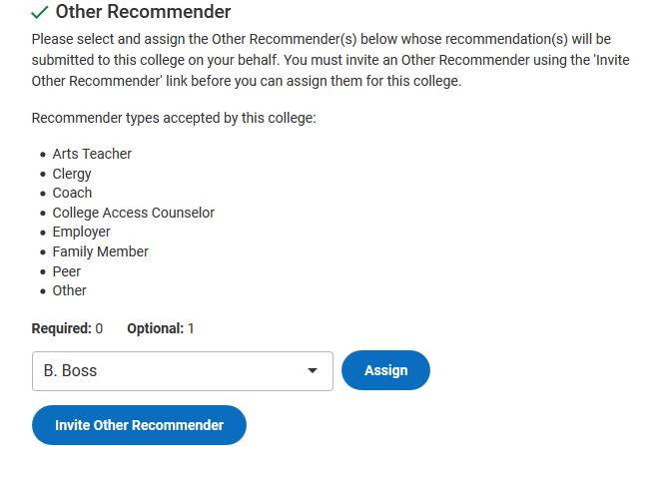

- You will need to repeat this assigning process for each of your schools and for each of your “Other Recommenders.”

- Your recommender will receive communication from Common App via email including instructions to create an account and upload a letter of recommendation.

