[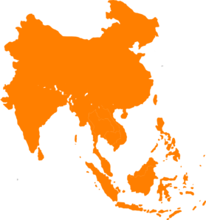](https://www.google.com/url?sa=i&rct=j&q=&esrc=s&source=images&cd=&cad=rja&uact=8&ved=0ahUKEwjcx_XEie7NAhWBNT4KHVPpCPYQjRwIBw&url=http://www.clker.com/clipart-southeast-asia.html&bvm=bv.126130881,d.cWw&psig=AFQjCNFWAjcX5aECrAIFBLv94mnnTAmF4w&ust=1468418014925889)

Southeast Asia

**Name:**

**Global History and Geography 9**

**SEG**

**Mr.Smith’s Class**

[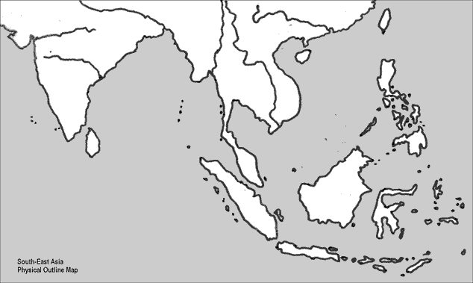](https://www.google.com/url?sa=i&rct=j&q=&esrc=s&source=images&cd=&cad=rja&uact=8&ved=0ahUKEwjUr9r8hu7NAhXCdz4KHUvxCCUQjRwIBw&url=http://www.washburn.edu/cas/history/stucker/SEastAsiaOutline.html&psig=AFQjCNHQ1Ly970uS9X_7ZHYB0YEsyKkY8w&ust=1468417330091915)Southeast Asia: Physical Geography

[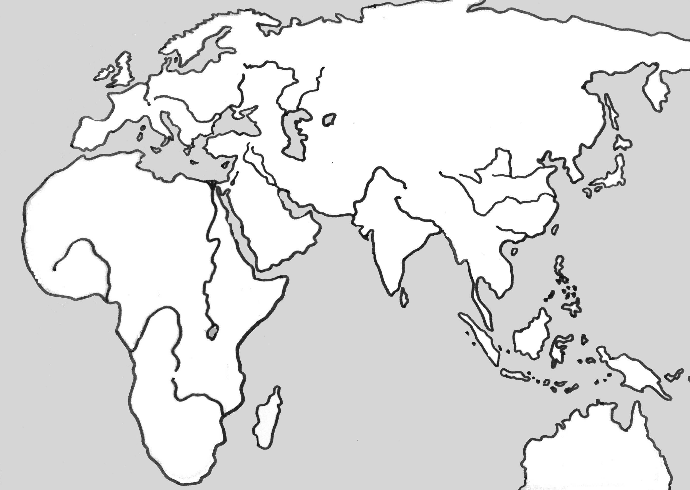](https://www.google.com/url?sa=i&rct=j&q=&esrc=s&source=images&cd=&cad=rja&uact=8&ved=0ahUKEwjmge2Clc3NAhVGMyYKHfG_CvAQjRwIBw&url=http://www.washburn.edu/cas/history/stucker/EHemisphereOutlineMap.html&bvm=bv.125801520,d.eWE&psig=AFQjCNEwz9k-3Y-YalKpgfFhYEr6fNOJMQ&ust=1467287226736187)

Early nations...

**Pagan Kingdom Khmer Empire**

**Srivijaya Empire Vietnam**

Be able to locate:

⚫Indian Ocean ⚫Philippine Sea ⚫Pacific Ocean ⚫South China Sea

⚫Java Sea ⚫Celebes Sea ⚫Andaman Sea ⚫Strait of Malacca

⚫Sumatra ⚫Borneo ⚫Java ⚫Sundra Strait

⚫Mekong River ⚫Chao Phraya River ⚫Red River ⚫India

⚫China ⚫The Philippines(islands)

During Video Notes SEN1 you will also be asked to color in four Ancient nations with four colors on the map above. Be sure to fill in the matching legend above by coloring in the boxes to match your map(use colored pencils, markers or highlighters).